# CS 255 System Design Document Template

## UML Diagrams

### UML Use Case Diagram

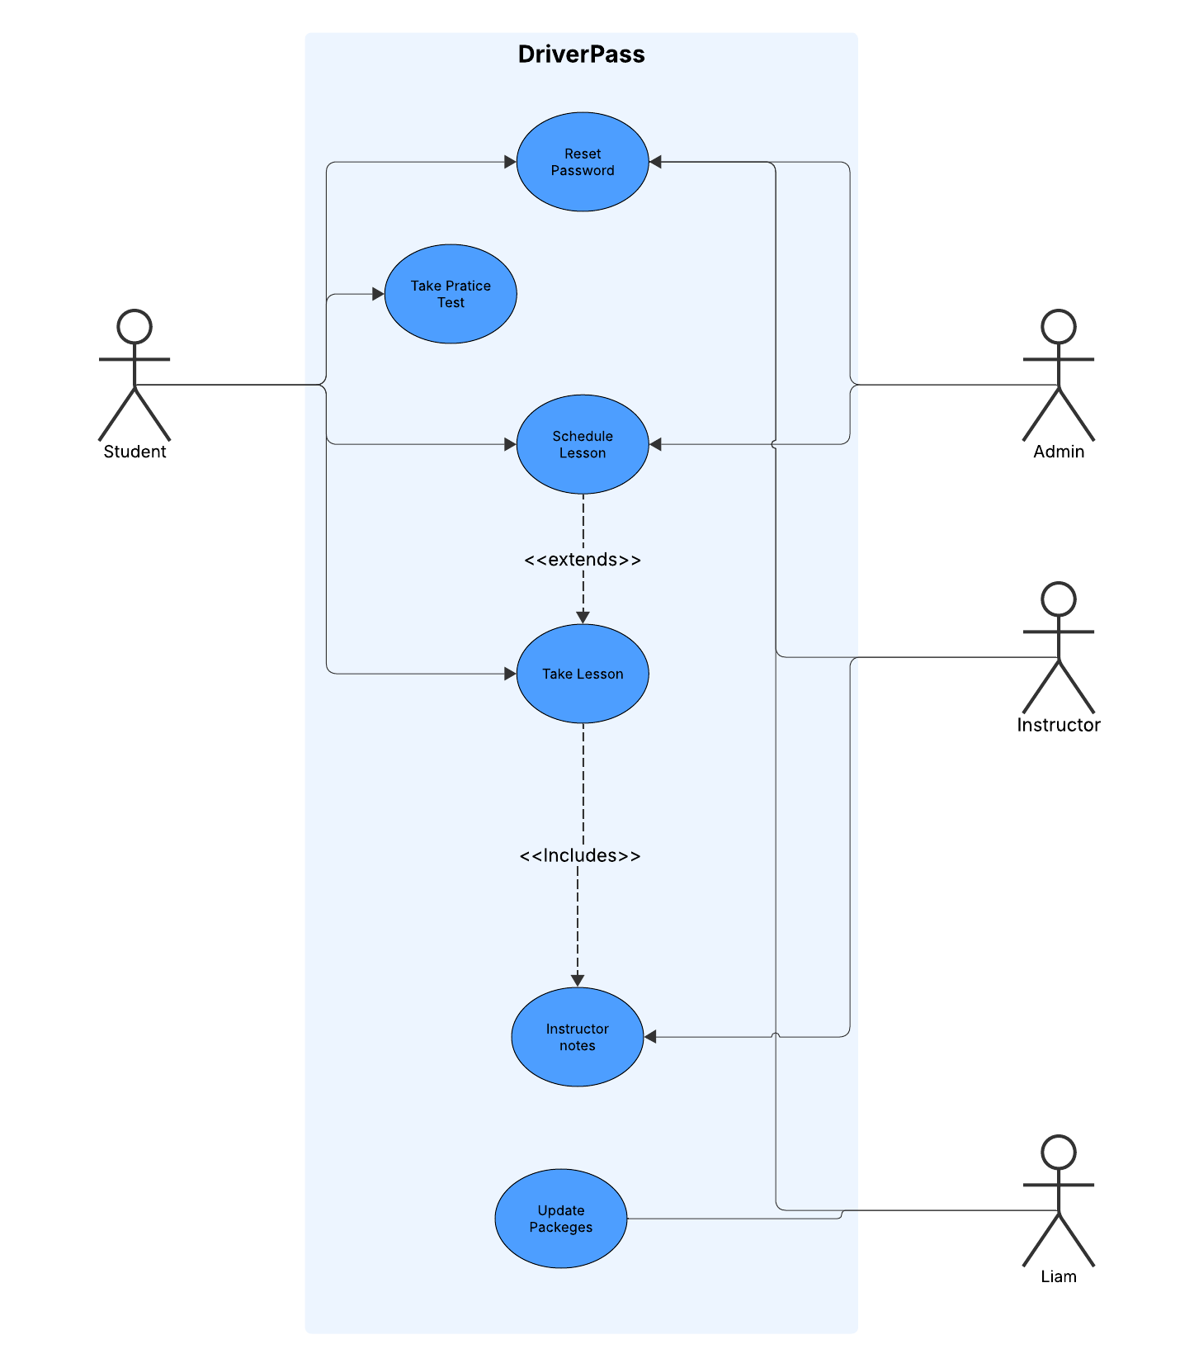

### UML Activity Diagrams

**Scheduling A Lesson**

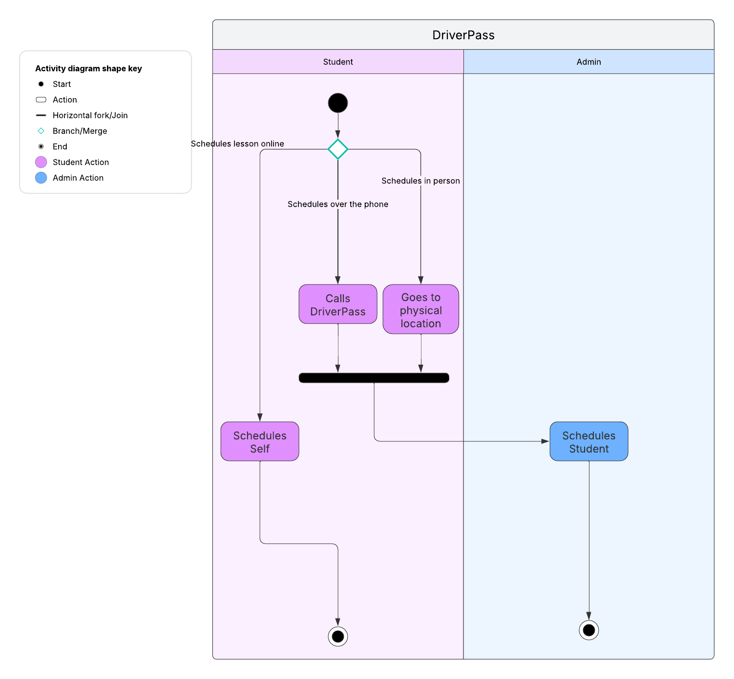

**Lesson**

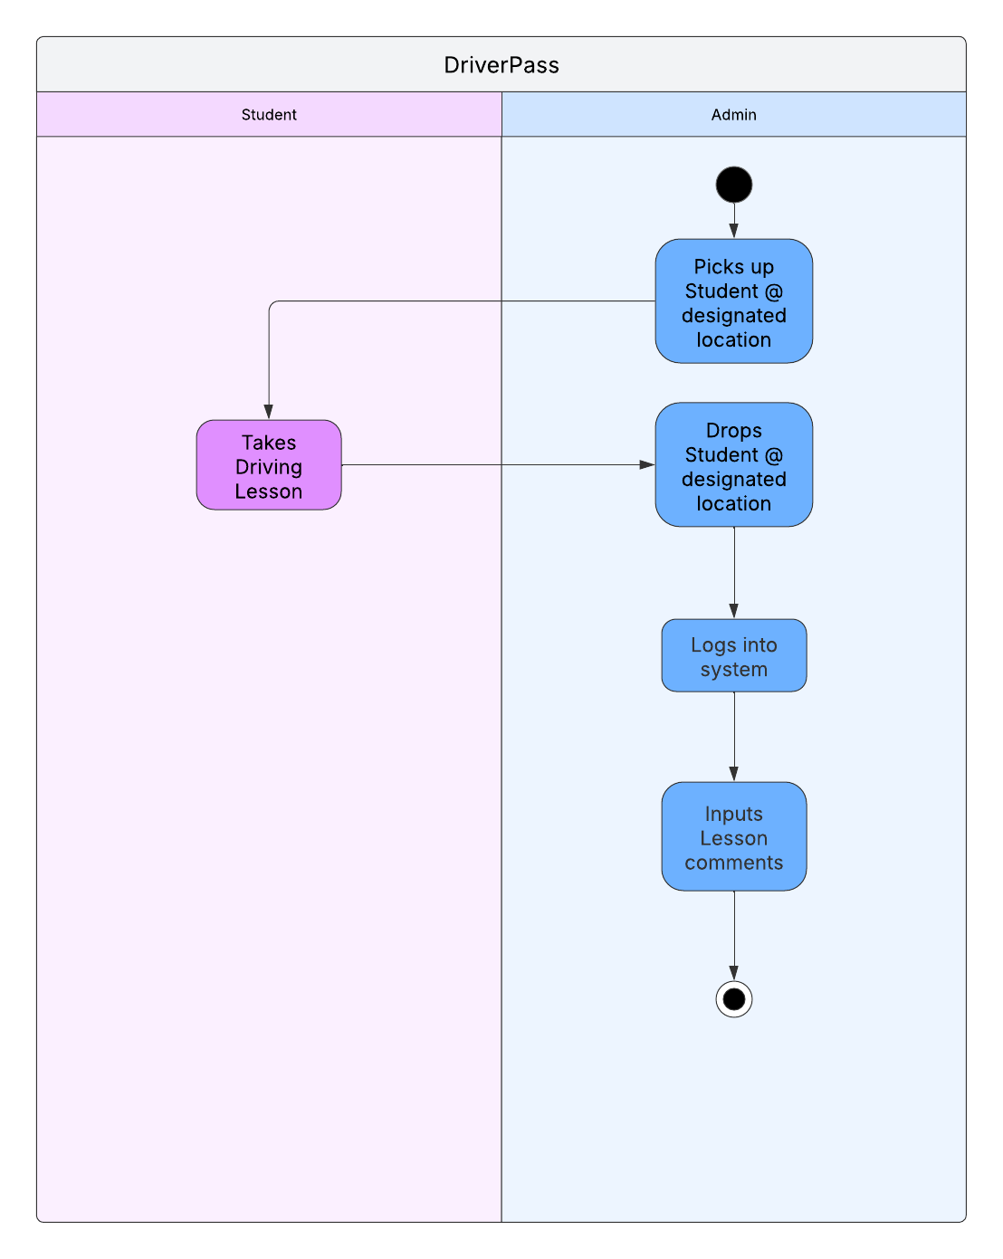

### UML Sequence Diagram

*[You were asked to create a sequence diagram based on* ***one*** *of the use cases you chose. Please insert your sequence diagram here. Check to make sure that you included appropriate components and symbols and that your design meets the client’s needs.]*

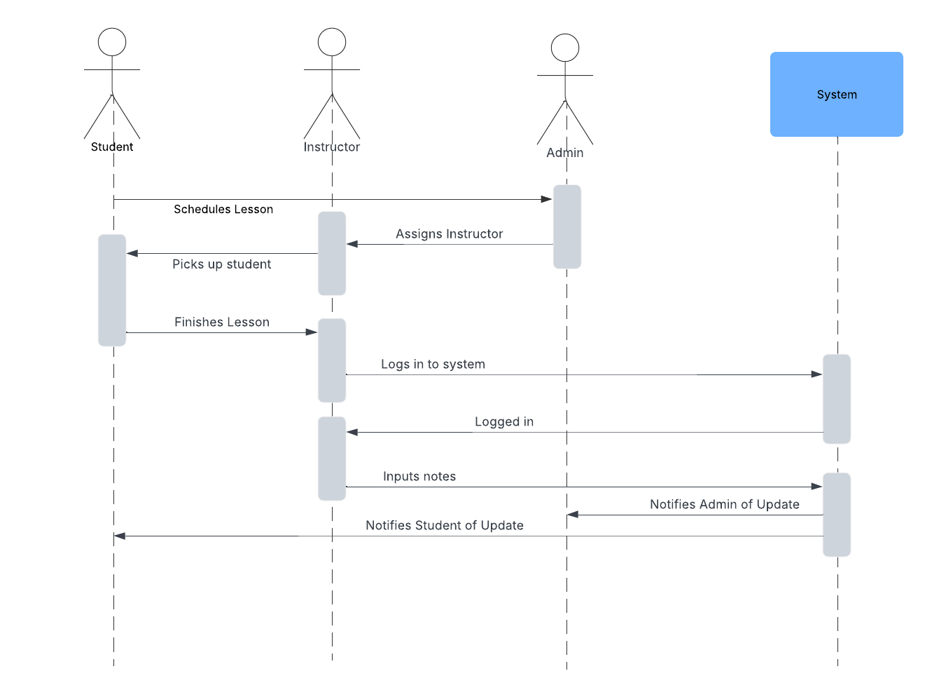

### UML Class Diagram

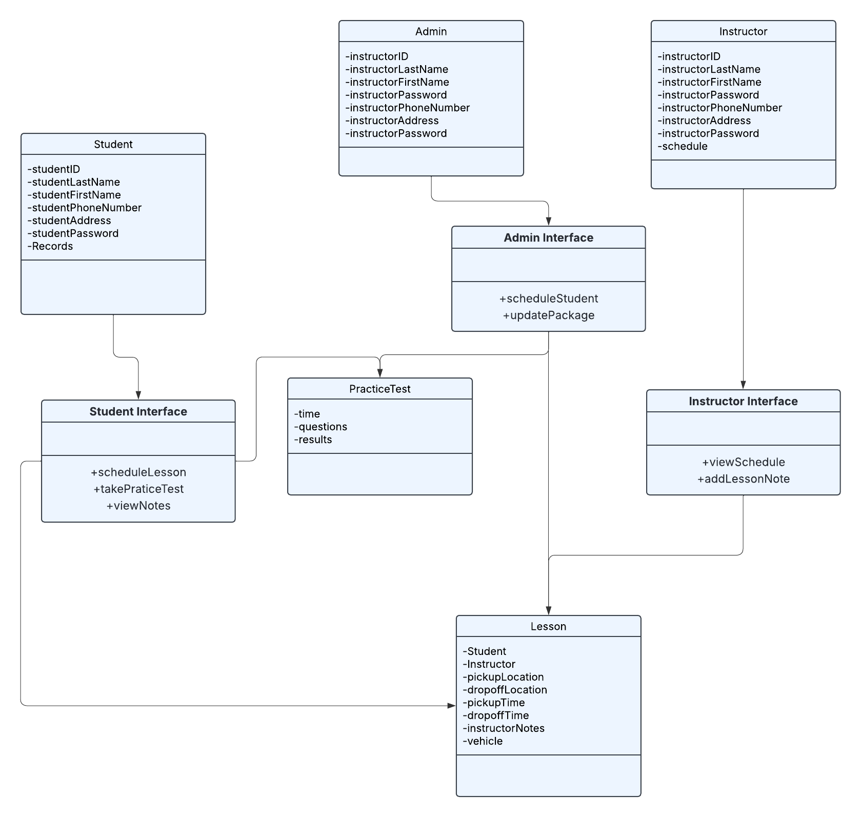

## Technical Requirements

Cloud Platform: AWS

AWS Resources:

* AWS Amplify
* S3 (storage)
* AWS encryption

Languages:

Javascript/Typescript

PostgreSQL

CSS

Downtime only on off-peak hours

Industry compliant security and accessibility

Users can only access controls necessary for the function of their job.

System should work with all major operating systems and web browsers.